 Horty, Springer & Mattern, P.C.
20 Stanwix Street, Suite 405 • Pittsburgh, PA 15222 • 412.687.7677 www.hortyspringer.com

CMS Requirements for Privileging Those Who Provide Medical Level of Care or Perform Surgical Tasks:

Since at least 2004, when the Director of CMS’s Survey and Certification Group issued a letter on the topic of Medical Staff privileging, the Centers for Medicare and Medicaid Services has referred to requirements that hospitals grant “clinical privileges” and provide for evaluation by the Medical Staff for anyone who provides a “medical level of care” or “conducts surgical procedures” (https://www.cms.gov/Medicare/Provider-Enrollment-and-Certification/SurveyCertificationGenInfo/downloads/SCLetter05-04.pdf).

The 2004 letter states, in relevant part:

The Medical Staff must periodically (defined as no less frequently than every 24 months in the absence of a State law that requires more frequent appraisals) conduct appraisals of individual current practitioners for continued or revised hospital privileges and must conduct individual appraisals of practitioner applicants requesting privileges. The Medical Staff must actually examine each individual practitioner’s qualifications and demonstrated competencies to perform each task/activity/privilege he/she has requested from the applicable scope of privileges for their category of practitioner. Components of practitioner qualifications and demonstrated competencies would include at least: current work practice, special training, quality of specific work, patient outcomes, education, maintenance of continuing education, adherence to medical staff rules, certifications, appropriate licensure, and currency of compliance with licensure requirements. All practitioners providing a medical level of care and/or conduct surgical procedures either directly or under supervision, whether employed by the hospital, physician or other entity, or contracted, must be individually evaluated. Board certification, certification, or licensure in and of itself is not recognized as an appropriate basis to bestow or award any or all of the privileges included in a particular practitioner’s category.

***

The hospital’s Governing Body and Medical Staff must assure that every individual practitioner who provides a medical level of care and/or who conducts surgical procedures in the hospital is competent to perform all granted privileges.

The purpose of the Medical Staff’s evaluation of each individual practitioner is to determine that a new applicant possesses the qualifications and competencies to have specific privileges granted or, in the case of current members of the medical staff, to evaluate the individual practitioner’s qualifications and demonstrated competencies in order to determine if that practitioner’s clinical privileges should be continued, discontinued, or revised. After the Medical Staff conducts its appraisal of individual practitioners, it makes recommendations to the Governing Body as to the extent of the privileges it is recommending be granted to each individual practitioner.

Reinforcing the 2004 letter, the Interpretive Guidelines (to the Medicare Conditions of Participation for Hospitals) state that if a hospital utilizes assistants to perform surgical tasks, CMS would expect those individuals to be granted privileges. This includes surgical PAs, RN First Assists (RNFAs), and surgical assistants (non-RN). (https://www.cms.gov/Regulations-and-Guidance/Guidance/Manuals/Downloads/som107ap_a_hospitals.pdf):

A-0945

(Rev. 37, Issued: 10-17-08; Effective/Implementation Date: 10-17-08)

§482.51(a)(4) - Surgical privileges must be delineated for all practitioners performing surgery in accordance with the competencies of each practitioner. The surgical service must maintain a roster of practitioners specifying the surgical privileges of each practitioner.

Interpretive Guidelines §482.51(a)(4)

Surgical privileges should be reviewed and updated at least every 2 years. A current roster listing each practitioner’s specific surgical privileges must be available in the surgical suite and area/location where the scheduling of surgical procedures is done. A current list of surgeons suspended from surgical privileges or whose surgical privileges have been restricted must also be retained in these areas/locations. The hospital must delineate the surgical privileges of all practitioners performing surgery and surgical procedures. The medical staff is accountable to the governing body for the quality of care provided to patients. The medical staff bylaws must include criteria for determining the privileges to be granted to an individual practitioner and a procedure for applying the criteria to individuals requesting privileges. Surgical privileges are granted in accordance with the competencies of each practitioner. The medical staff appraisal procedures must evaluate each individual practitioner’s training, education, experience, and demonstrated competence as established by the hospital’s QAPI program, credentialing process, the practitioner’s adherence to hospital policies and procedures, and in accordance with scope of practice and other State laws and regulations.

The hospital must specify the surgical privileges for each practitioner that performs surgical tasks. This would include practitioners such as MD/DO, dentists, oral surgeons, podiatrists, RN first assistants, nurse practitioners, surgical physician assistants, surgical technicians, etc. When a practitioner may perform certain surgical procedures under supervision, the specific tasks/procedures and the degree of supervision (to include whether or not the supervising practitioner is physically present in the same OR, in line of sight of the practitioner being supervised) be delineated in that practitioner’s surgical privileges and included on the surgical roster.

If the hospital utilizes RN First Assistants, surgical PA, or other non-MD/DO surgical assistants, the hospital must establish criteria, qualifications and a credentialing process to grant specific privileges to individual practitioners based on each individual practitioner’s compliance with the privileging/credentialing criteria and in accordance with Federal and State laws and regulations. This would include surgical services tasks conducted by these practitioners while under the supervision of an MD/DO.

When practitioners whose scope of practice for conducting surgical procedures requires the direct supervision of an MD/DO surgeon, the term “supervision” would mean the supervising MD/DO surgeon is present in the same room, working with the same patient.

Surgery and all surgical procedures must be conducted by a practitioner who meets the medical staff criteria and procedures for the privileges granted, who has been granted specific surgical privileges by the governing body in accordance with those criteria, and who is working within the scope of those granted and documented privileges.

There has always been some level of ambiguity about what type of evaluation is truly required for surgical assistants and RNFAs, because CMS did not define what constituted a “surgical task” or a “medical level of care,” leaving many hospitals to ask whether making an incision is a surgical task. Or what about sutures?

It has been years (20 years!) since CMS first announced its expectations for RNFAs and surgical assistants to be granted “clinical privileges.” For the vast majority of those years, we were not aware of any hospitals that had been cited by CMS or any of the accrediting bodies for failing to grant clinical privileges to surgical assistants or RNFAs. Many hospitals and medical staffs decided to take a “wait and see” approach (wait to see if enforcement of the guidance would begin, through investigations or accreditation surveys).

As the years passed, some began to privilege those who performed surgical tasks – turning to their own best judgment of what might constitute a surgical tasks of sufficient seriousness to require privileges. Of those, many looked to a provision within the State Operations Manual that discusses informed consent requirements, because that section discusses “important surgical tasks” (since anyone performing an important surgical task is required by the COPs to be listed on the informed consent form).

Within that section, an important surgical task is defined to include, ”opening and closing, dissecting tissue, removing tissue, harvesting grafts, transplanting tissue, administering anesthesia, implanting devices and placing invasive lines.” Accordingly, many hospitals chose to infer that anyone who performs any one of those tasks would likely be performing a “surgical task” according to CMS and, in turn, would need to be granted clinical privileges for those activities.

DNV Standards:

While the DNV accreditation standards for hospitals have always included language requiring privileges for those who perform surgical tasks, the language was updated when the 2023 standards were published, to clarify and more closely align with CMS’s standards. The 2023 standards, therefore, included more details and, for the first time, specifically mentioned RN First Assists (https://brandcentral.dnv.com/download/DownloadGateway.dll?h=BE1B38BB718539CC0AB58A5FF2EA7A83DB81B540E9C9F6E10527F226501E0ADCBB04D01D02F721A8ECBAA6DC2726FC17&_ga=2.193943725.1012878289.1695034650-1642551338.1695034650&_gl=1*1r1sr19*_ga*MTY0MjU1MTMzOC4xNjk1MDM0NjUw*_ga_S064SE6ZM3*MTY5NTAzNDY1MC4xLjEuMTY5NTAzODMxMS4wLjAuMA..):

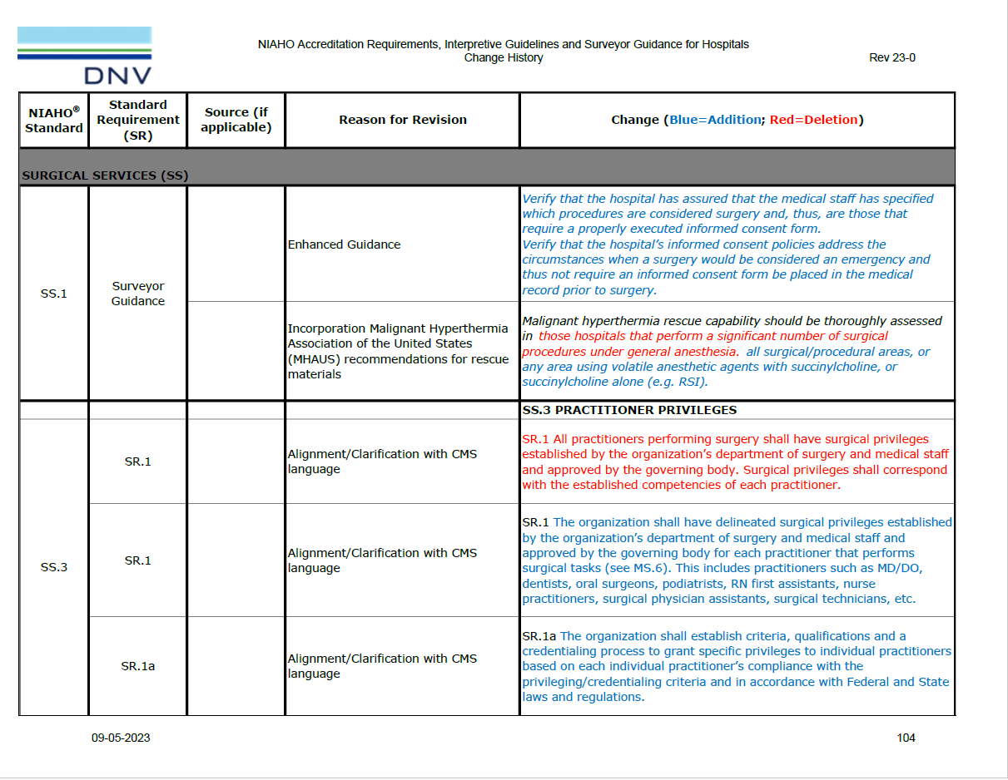

The current standards (Revision 24-0, which became effective March 2024) continue to include language regarding surgical tasks performed by non-physician practitioners that closely mirrors that found in CMS’s Interpretive Guidelines to the Medicare Conditions of Participation:

SS.8 OPERATIVE REPORT

SR.1 An operative report describing techniques, findings, and tissues removed or altered shall be dictated or documented and authenticated by the surgeon immediately following surgery. The operative report will contain at least the following:

***

SR.1c Name(s) of the surgeon(s) and assistants or other practitioners who performed surgical tasks (even when performing those tasks under supervision);

***

SR.1j Surgeons or practitioners name(s) and a description of the specific significant surgical tasks that were conducted by practitioners other than the primary surgeon/practitioner (significant surgical tasks include: opening and closing, harvesting grafts, dissecting tissue, removing tissue, implanting devices, altering tissues); and,

***
Example of a Well-Designed Informed Consent Process
A well-designed informed consent process would include discussion of the following elements:
***
Whether physicians other than the operating practitioner, including but not limited to residents, will be performing important tasks related to the surgery, in accordance with the hospital’s policies. Important surgical tasks include opening and closing, dissecting tissue, removing tissue, harvesting grafts, transplanting tissue, administering anesthesia, implanting devices and placing invasive lines.

***

Whether, as permitted by State law, qualified medical practitioners who are not physicians will perform important parts of the surgery or administer the anesthesia, and if so, the types of tasks each type of practitioner will carry out; and that such practitioners will be performing only tasks within their scope of practice for which they have been granted privileges by the hospital.

***

SS.3 PRACTITIONER PRIVILEGES

SR.1 The organization shall have delineated surgical privileges established by the organization’s department of surgery and medical staff and approved by the governing body for each practitioner that performs surgical tasks (see MS.6). This includes practitioners such as MD/DO, dentists, oral surgeons, podiatrists, RN first assistants, nurse practitioners, surgical physician assistants, surgical technicians, etc.

SR.1a The organization shall establish criteria, qualifications and a credentialing process to grant specific privileges to individual practitioners based on each individual practitioner’s compliance with the privileging/credentialing criteria and in accordance with Federal and State laws and regulations.

SR.1a(1) This would include surgical services tasks conducted by these practitioners while under the supervision of an MD/DO.

***
Interpretive Guidelines:
A current roster listing each practitioner’s specific surgical privileges shall be available in the surgical suite and area/location where the scheduling of surgical procedures is done. A current list of surgeons suspended from surgical privileges or whose surgical privileges have been restricted shall also be retained in these areas/locations.

The hospital shall delineate the surgical privileges of all practitioners performing surgery and surgical procedures. (This would include practitioners such as MD/DO, dentists, oral surgeons, podiatrists, RN first assistants, nurse practitioners, surgical physician assistants, surgical technicians, etc.) The medical staff is accountable to the governing body for the quality of care provided to patients. The medical staff bylaws shall include criteria for determining the privileges to be granted to an individual practitioner and a procedure for applying the criteria to individuals requesting privileges. Surgical privileges are granted in accordance with the competencies of each practitioner. The medical staff appraisal procedures shall evaluate each individual practitioner’s training, education, experience, and demonstrated competence as established by the hospital’s QAPI program, credentialing process, the practitioner’s adherence to hospital policies and procedures, and in accordance with scope of practice and other State laws and regulations.

If the hospital utilizes RN First Assistants, surgical PA, or other non-MD/DO surgical assistants, the hospital shall establish criteria, qualifications and a credentialing process to grant specific privileges to individual practitioners based on each individual practitioner’s compliance with the privileging/credentialing criteria and in accordance with Federal and State laws and regulations. This would include surgical services tasks conducted by these practitioners while under the supervision of an MD/DO.

When a practitioner may perform certain surgical procedures under supervision, the specific tasks/procedures and the degree of supervision (to include whether or not the supervising practitioner is physically present in the same OR, in line of sight of the practitioner being supervised) shall be delineated in that practitioner’s surgical privileges and included on the surgical roster.

When practitioners whose scope of practice for conducting surgical procedures requires the direct supervision of an MD/DO surgeon, the term “supervision” would mean the supervising MD/DO surgeon is present in the same room, working with the same patient.

Recent Enforcement Action and Next Steps

During the course of 2024, we have begun receiving reports that hospitals are being cited by DNV for failing to privilege surgical technicians who perform surgical tasks. Accordingly, it is safe to assume that enforcement related to this standard is on at least some surveyors’ radar. Other organizations accredited by DNV should take note and give serious consideration to privileging RNFAs and surgical technicians, without delay. We heard anecdotal reports that surveyors did not provide the cited organizations with a great deal of time to “catch up” on the credentialing of these practitioners once the citation was noted. Accordingly, getting into compliance before you get cited may be the best way to avoid scrambling while under survey.

We still have not heard of any hospitals being cited on this topic by the Joint Commission or CMS itself. But, given what is going on with DNV, organizations accredited by other organizations (or not accredited at all) may wish to reconsider whether it makes sense to roll surgical technicians and RNFAs into the Medical Staff credentialing and privileging processes (and, in turn, incorporate those practitioners into the organizations’ professional practice evaluation processes).

